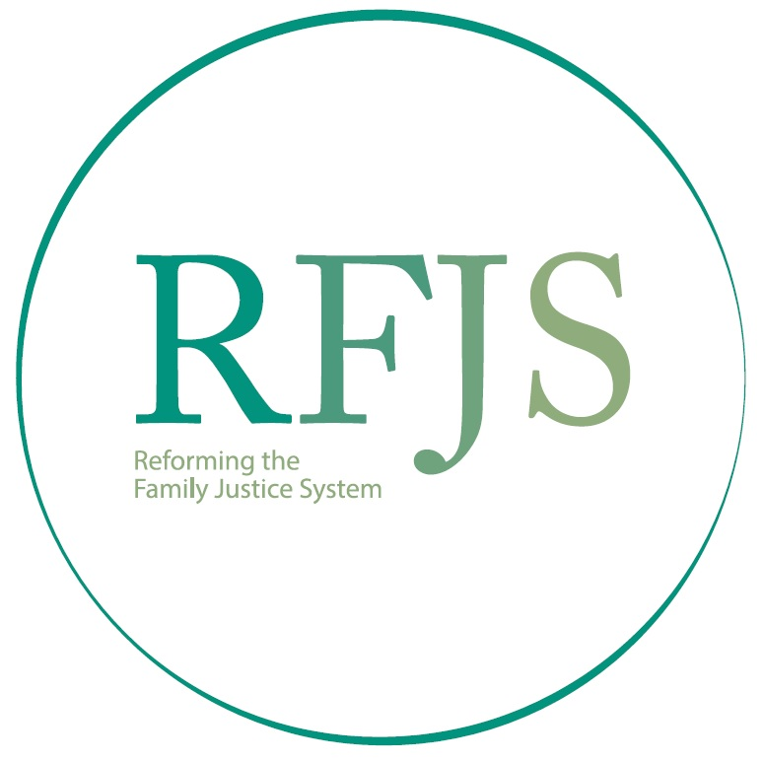

GRANDE PRAIRIE PILOT PROJECT:
FAMILY LAW PRE-COURT SYSTEM ENGAGEMENT

RFJS ACTION TEAM – COMMENTARY

ON THE

COURT OF KING’S BENCH OF ALBERTA

NOTICE TO THE PROFESSION AND PUBLIC

Published October 4, 2024
https://albertacourts.ca/docs/default-source/qb/npp-2024-10-04-grande-prairie-pilot-project.pdf?sfvrsn=3c10982_7

The community of Grande Prairie has been engaged in a process to transform the family justice system since March 2020, when the RFJS initiative first began to meet with collaborators who are concerned with improving outcomes for families. The community is engaged, networked, and has supports and skills-building programs to assist families with their social, relationship, parenting, financial, health and legal needs.

The Pilot proposal was developed with input from the Grande Prairie collaborators, and once the Pilot was approved by the Court, an Action Team was created to develop the Notice to the Profession and Public for the Court. The Action Team has developed a commentary on the Notice to the Profession and Public, which is set out below.

Effective October 21, 2024, the Court will initiate a pilot project in the Judicial Centre of Grande Prairie, to support the work of the Reforming the Family Justice System (RFJS) initiative and the Grande Prairie community. The goal is to reduce the risk of toxic stress experienced by families, particularly children, which is increased by adversarial legal processes. Family litigants will be expected and empowered to seek the skills and supports to address the social, relationship, parenting, financial and health needs that arise during family restructuring. | Commentary  This pilot is consistent with the evidence of brain science and resilience. There is now very solid scientific evidence showing the short and long-term impacts of early childhood adversity on both the development of children’s brains (neuro-development), and on changes to gene expression (epigenetic changes). Well and broadly known studies show linkages between Adverse Childhood Experiences (ACEs) and bad outcomes.  The term “ACEs” is an acronym for Adverse Childhood Experiences …. “ACEs” referred to three specific kinds of adversity children faced in the home environment—various forms of physical and emotional abuse, neglect, and household dysfunction. (ACEs and Toxic Stress: Frequently Asked Questions, Harvard Center on the Developing Child, https://developingchild.harvard.edu/resources/aces-and-toxic-stress-frequently-asked-questions/ )  ACEs are directly relevant to family justice issues in this way:  Separation and divorce is one of the ten ACEs. The three categories of ACEs: abuse, neglect and other household dysfunction, also arise in child welfare and family violence matters. The family justice system often exacerbates, even causes, toxic stress for children and adults involved with it, because it is based on an adversarial model of dispute resolution that encourages a win-lose paradigm of conflict, rather than de-escalating conflict and creating conditions for collaborative decision-making. Parents can be caught up in a downward spiral that becomes about winning or losing, rather than acting in ways that reduce stress and support their child’s brain development and resilience. Unfortunately, the removal of children from their family home and the incarceration of a parent are themselves ACEs. The responses the justice system has often had to these situations, have actually added to the adverse experiences of children in these families. (From Jerke J, “The Story of Re-Imagining the Family Justice System: Study Leave Report” (May 25, 2023) at pages 14-17).  The Court pilot is aligned with community efforts in Grande Prairie to reduce sources of toxic stress for families, to support responsive relationships, and to strengthen core life skills.  Resources:  Felitti, V.J. “Relationship of Childhood Abuse and Household Dysfunction to Many of the Leading Causes of Death in Adults: The Adverse Childhood Experiences (ACE) Study, American Journal of Preventive Medicine, 1998 May; 14(4):245-58  ACEs and Toxic Stress: Frequently Asked Questions, Harvard Center on the Developing Child, https://developingchild.harvard.edu/resources/aces-and-toxic-stress-frequently-asked-questions/  Three Principles to Improve Outcomes for Children and Families, Harvard Center on the Developing Child, https://developingchild.harvard.edu/resources/three-early-childhood-development-principles-improve-child-family-outcomes/  “How Brains Are Built”, video produced by the Alberta Family Wellness Initiative, October 2013, https://www.youtube.com/watch?v=LmVWOe1ky8s  “Brains Journey to Resilience”, video produced by the Alberta Family Wellness Initiative, November 2017, https://www.youtube.com/watch?v=HJvDrT6N-mw
Effective October 21, 2024, before appearing before the Court of King’s Bench in the Judicial Centre of Grande Prairie in any family law application to which Part 12 of the Rules of Court applies, all parties will be expected, with the assistance of Counsel if available, to take the following steps:  - Identify the social, relationship, parenting, financial, and health challenges the family is experiencing;  - Obtain appropriate supports, including building necessary skills, to help families address their social, relationship, parenting, financial and health issues;  - Work to reach appropriate agreements about their family matters including legal issues, with or without the assistance of resolution tools and Alternative Dispute Resolution (ADR) processes. | Commentary  Most challenges in family restructuring arise from social needs, relationships, parenting arrangements, financial arrangements and health needs. There may also be a legal element to these.  In the past, family issues have tended to be understood as legal issues, but that has meant that families have turned to law and legal processes, when really they need supports for the many questions and challenges that arise as their family restructures. They will need to decide where each of them will live. They will work out their parenting arrangements including which parent the children will live with, arrangements for the other parent to spend time with them, who will make decisions about day-to-day matters and about the big decisions in their children’s lives. They will need to work out financial arrangements including how they will pay for two households, divide their property, and ensure that they are able to meet their financial commitments. These are hard decisions, made more difficult by the emotions that surround the ending of their marital relationship. There may be feelings of anger, fear and even despair.  These are normal for a couple to experience, but are not really legal in nature. Families are encouraged to find social supports to assist them to work through these life challenges. Some of the ways that those supports can assist, will be to help navigate the changes that are taking place in the lives of this family. And to teach and coach new skills. Perhaps basic skills about finances and meal planning. About communication. And co-parenting children. (Extracted from “Re-Imagining Family Justice: Telling A New Story About Separation and Divorce”, Justice Rod Jerke and Diana Lowe, KC, Life Changes and Divorce Magazine, Spring 2024, pp 10-11 https://issuu.com/uglowgrl/docs/spring_dmc_2024 )  Similar to the process related to streamlined trials (see Rule 8.27), no Affidavit will be required to satisfy this expectation. The Court will have reference to the pleadings, statements by the parties, and other relevant information, if any.  The Court recognizes many forms of ADR processes, as set out in the Participation in Alternative Dispute Resolution Form (online: https://www.albertacourts.ca/docs/default-source/qb/participation_in_adr.pdf?sfvrsn=e7af5382_5 ). The RFJS encourages the adoption of all of these processes, as a means of helping families to reach a good agreement.  The Court is currently considering whether a form may be of assistance, but that will be determined as we gain experience.
Parties are expected to seek assistance with their family challenges. In Grande Prairie, they can do so through the Family Resource Network Hub at this link: https://www.familyeducationsociety.org/. | Commentary  There are a variety of community and natural supports that can help separating couples to build new pathways forward for themselves and for their children. If they need help finding supports, parties can begin with the Grande Prairie Family Resource Network or Hub, which will help them to identify programs or services available in the community.  The Grande Prairie community has worked hard to identify, align and enhance a multitude of skill-building programs and supports available in this community.  There are also many professionals who can assist families to reach an agreement, and many approaches to resolving legal questions or narrowing the issues, including:  - Lawyers who provide advice and help parties to understand their legal rights and responsibilities  - Mediators  - Collaborative professionals  - Restorative facilitators  - Peacebuilding programs  - Indigenous practices  Ideally all of this will be written into an agreement that sets out the new family arrangements.
In any family law application, the judge will ask the parties or their Counsel what they are hoping to get help with, what they have been able to agree to, and what remains to be addressed.  The discussion will include:  - Questions to help the judge distinguish between the non-legal family challenges (which are the social, relationship, parenting, financial or health challenges that occur in family situations) and the legal issues which arise from rights and responsibilities under the law;  - What supports and skill-building assistance they have obtained, so it can be determined whether further directions are needed;  - Whether they have obtained legal advice, or sought assistance to resolve their legal issues, so it can be determined whether further directions are needed.  Counsel or the parties will also be asked whether there are concerns relating to safety and the potential for harm to any children, or to the parties. Evidence relevant to this concern should be set out in an Affidavit. | Commentary  Focusing on adversarial legal processes has not served families well. Rather than ensuring that all of the needs of families are being met through supports and skills, it tends to channel people’s attention in to fighting about these issues and provides them with tools for fighting.  There are many important justice system reports that have called for change. Until recently, the changes have been focused on improving and amending court processes and legal supports. The assumption has been that separation and divorce would involve court determination about disputes, and that day-to-day decisions in our lives are “disputes”. Really these are “decisions” that most parents can make about where they will live, the things they can do to live fully, and how they will love their children and support them to grow up well. And if there are still unresolved questions, families can mediate or use other ways to make these important decisions, rather than litigate.  While sometimes necessary, family litigation too often ends in serious financial and emotional costs from fighting things out in Court; in families that have not sought out the kind of supports and skills that focus on their family’s well-being; and in children who have suffered through the toxic stress of a family that is essentially a battle zone. (Extracted from “Re-Imagining Family Justice: Telling A New Story About Separation and Divorce”, Justice Rod Jerke and Diana Lowe, KC, Life Changes and Divorce Magazine, Spring 2024, pp 10-11. https://issuu.com/uglowgrl/docs/spring_dmc_2024).  For a more detailed report, see “Meaningful Change for Family Justice: Beyond Wise Words (2013)https://static1.squarespace.com/static/60804beaba3bc03016513a59/t/61620f1e0a00fb64019fb0e8/1633816351446/Report+of+the+Family+Law+WG+Meaningful+Change+April+2013.pdf  Access to Civil and Family Justice: A Roadmap for Change (2013): https://static1.squarespace.com/static/60804beaba3bc03016513a59/t/6148d41ec33dd65ced337f8d/1632162847278/RoadmapForChange.pdf  Jerke J, “The Story of Re-Imagining the Family Justice System: Study Leave Report” (May 25, 2023)  The Pilot is part of the Grande Prairie community movement to create a new way forward for families.  This Court of King’s Bench pilot is strategically aligned with efforts in the community of Grande Prairie to create a different path for families, to reduce the reliance on legal adversarial processes, and to ensure that they obtain the kinds of skills and supports that they need, outside of legal adversarial processes. The Court and the community have worked collaboratively to create this opportunity.  The parties can expect to be asked to describe what they have done to address the family challenges they are dealing with. If the parties haven’t taken advantage of the opportunities available to them, they may be directed to the Hub or to a form of resolution for legal issues.
Where there is a harm or risk of harm (including the potential for children to experience Adverse Childhood Experiences, or ACEs), the judge will make decisions to promote safety including measures to reduce the risk of toxic stress on children.  Where there is no harm or risk of harm (including the potential for children to experience ACEs), the judge will determine whether there are any matters that are urgent or important and may make decisions as appropriate and available on the evidence.  The judge hearing an application may make an order:  - Requiring parties to pursue skill-building and supports for non-legal challenges;  - For a resolution process to be used to resolve legal issues;  - For an Interim Order, where appropriate, to reduce the opportunity for ongoing disputes pending final resolution;  - For a final resolution by Binding JDR (if agreed, see Rule 4.18), Streamlined Trial, or full trial, supported by a procedural order to ensure timely resolution. | Commentary  Refer to the commentary above, regarding the supports and skills building that is available in the community to address the social, relationship, parenting, financial and health challenges that families are dealing with, and the professionals who can assist families to reach an agreement, through many approaches to resolving legal questions or narrowing the issues
Consent Orders are encouraged, as these represent agreement on legal issues and on the social, relationship, parenting, financial and health challenges the family has been able to address.

